Requirements:

1. Oracle virtual box or VMware latest versions needs to be preinstalled in your system.
2. Fedora 20 or latest version fedora 22 .ISO image of file.
We can get it from the below link which is for free
https://getfedora.org/en/workstation/download/

3. RAM size minimum 4GB, but 8GB is recommendable for better performance.
4. System with dual core or multi core processor to support proper working of virtual machine.
5. Admin privileges to that system.

Installation:

1. On the Virtual Box Manager, click New.

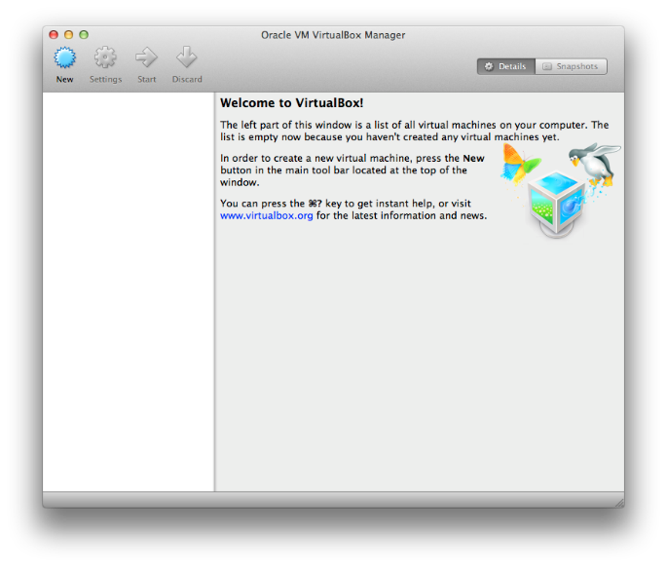

2. Then give the name of the virtual machine, select type as Linux and version as fedora (64 bit).Click on continue.

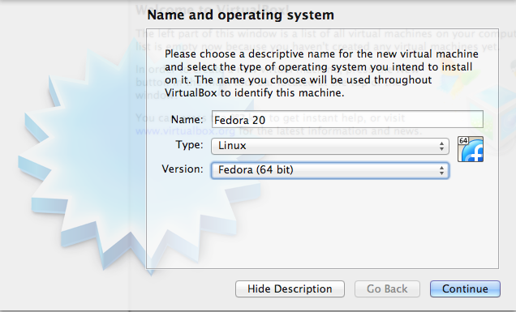

3. Then it will ask for RAM memory size. You can give it as 2048MB or 4096MB depends on the resource availability. But minimum 2GB memory size is needed for installation. After that click on continue button.

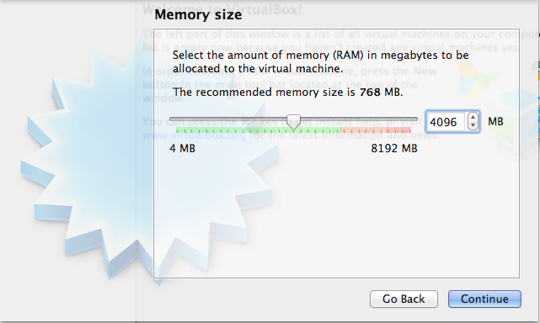

4. Then you will get hard drive page. There you have three options, based on your requirement you need to select the option. If you want to delete all the working files and free the RAM then you need to select one of the bottom two options. Then click on continue.

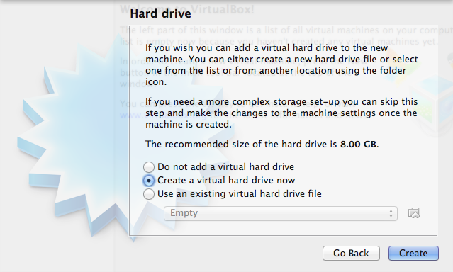

5. Select hardware file type as VDI, which is a default option. Through this we can secure information from being corrupted. Then click on continue.

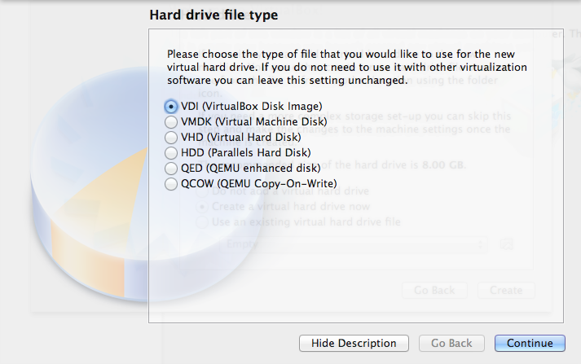

6. Use default dynamically allocated option. This will allow us to extend the memory space in case of any future need. Click Continue.

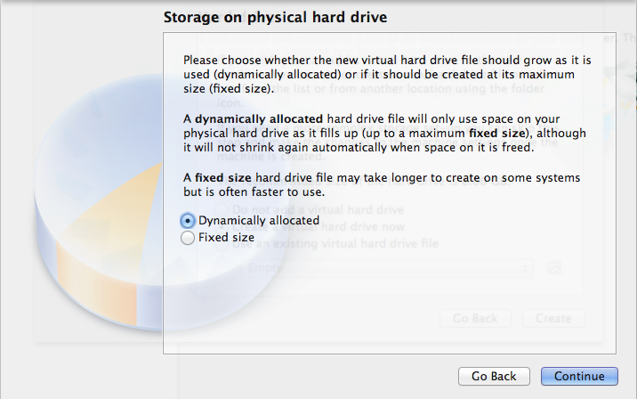

7. Here you need to give virtual hardware name, and select the hard drive space. I recommend to give it as 50GB if you are using it for intensive use. Then click on Create

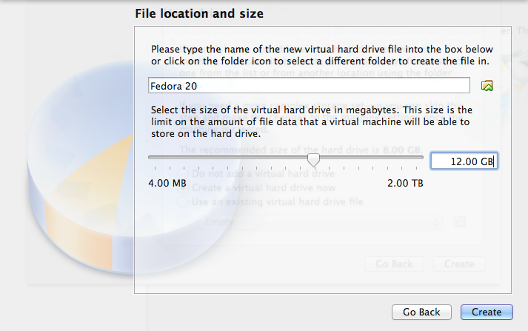

8. After completing the above steps you will get Virtual Box Manager page with configuration details.

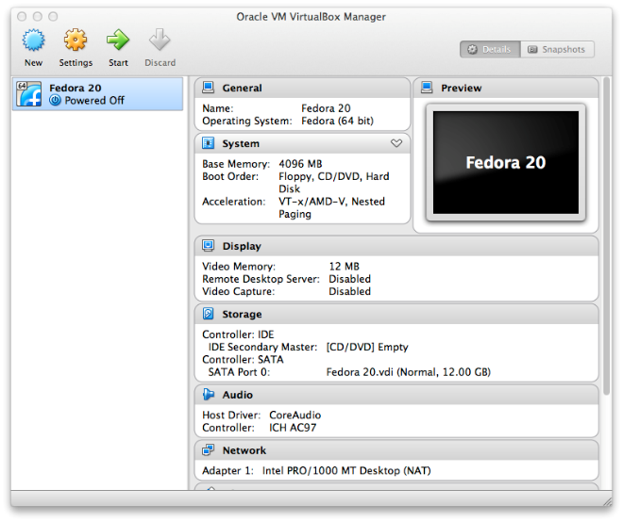

9. Click on start arrow and select image file from your machine in select start-up disk. Then click on start.

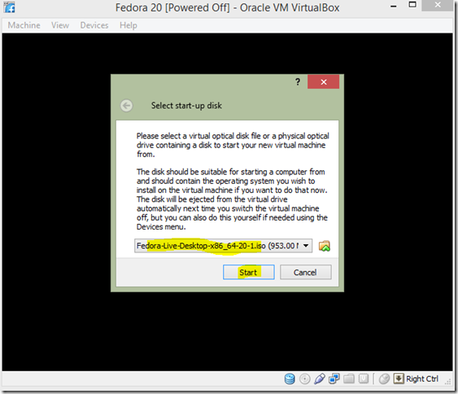

10. Select “Install to Hard Driver” option.

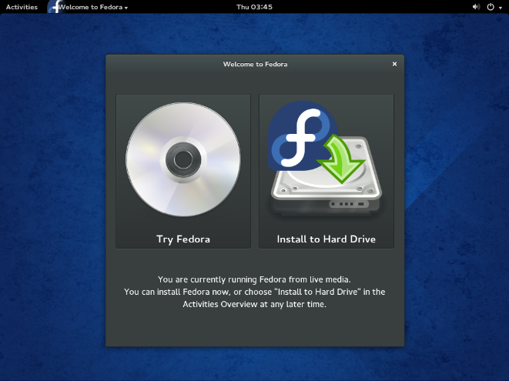

11. Select the language you want to use.

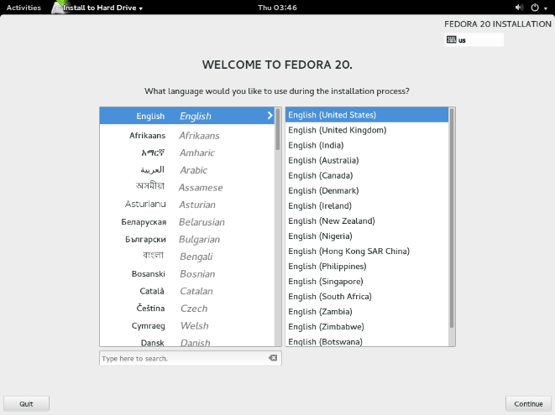

12. Choose each item from Installation summary menu do the necessary changes.
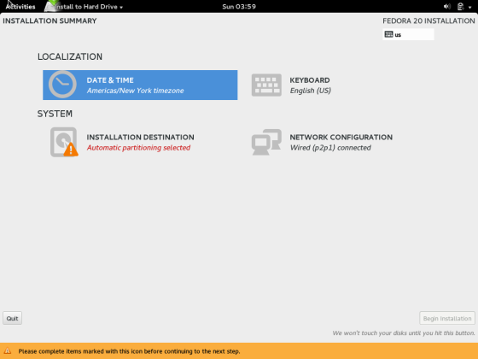

13. Select Installation Destination from the full installation Summary Menu to select and partition the disks Fedora will be installed on. Then press done.

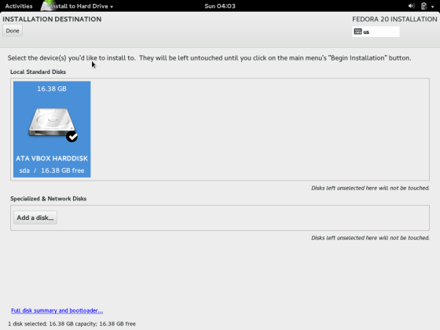

14. The Installation Options dialog now appears, informing you if there is enough space on the selected drive to install Fedora.

Select I want to review/modify my disks before continuing to create and edit the partitions yourself, then click Continue to reach the Manual Partitioning section.
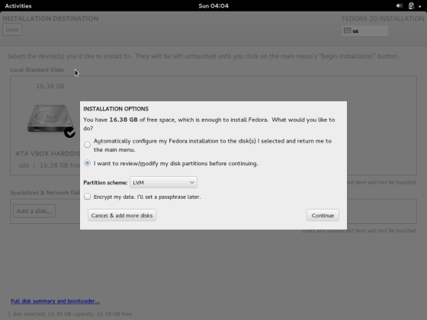

15. Then you will get manual partitioning page. Based on the space available you can create more partitions by clicking on '+' button. After that click on done once we are done with partitioning.

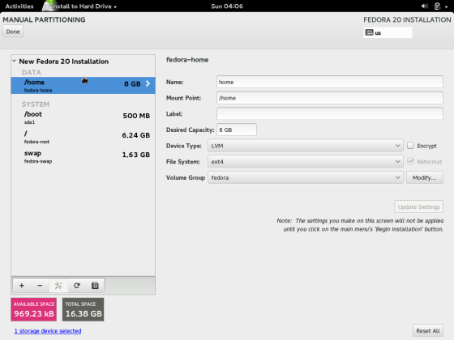

16. Click on Begin installation in installation summary menu screen.

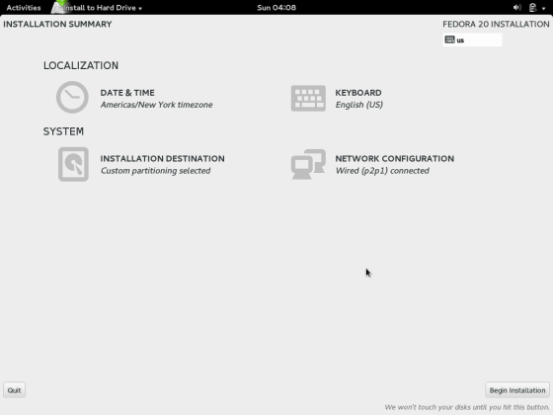

17. Give root password. And create users if you want to create

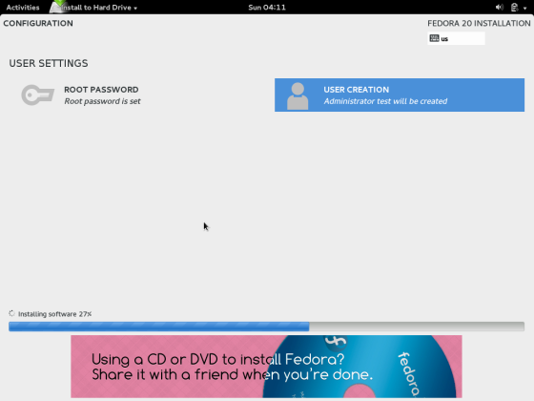
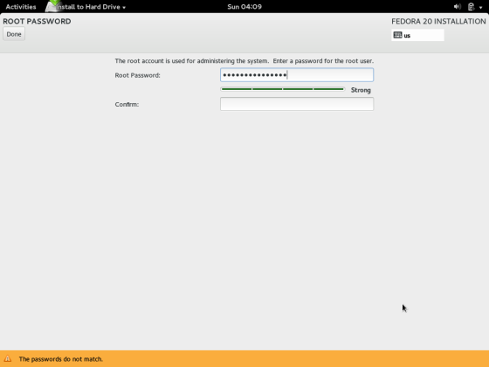

Once we are done with this, our fedora operating system is ready to use.

